Appendix 9 New Features in v2.4 C
Version 2.4C adds several features, which include:

New Suspension Types or Options
Roll Center for Double A Arm and McPhearson Strut suspensions are now calculate using the Force Based Roll Center methodology. This method is more accurate and realistic. You will no longer see roll centers being calculated, say, 50 or 1000 inches beyond the track of the car, which made very little sense. There is a Preference Setting which lets you revert back to the old “Kinematic” method of calculating Roll Center, which was what we did before this new v2.4C. Figs A 6.50 and A 6.51.

De Dion rear suspension is now one of the Rear Suspension Types you can choose from. The De Dion is somewhat of a hybrid. It is like a independent rear suspension in that the differential or transaxle is mounted to the chasses, eliminating unsprung weight. But for suspension geometry, it is like a solid axle (live axle). There is a beam that solidly connects the wheel spindles on right and left. Fig A 6.52.

You can now specify a Jacob’s Ladder as a possible “lateral locator” for solid axle suspensions. Fig A 6.53.

Now if you specify either end of the car as having traction (driving tires) and the suspension type is independent, fields open up for you to enter the location of the center’s of the CV or U joints. The program will calculate the length of the half shafts connecting these 2 joints. Then when you have the suspension go through motion, the program will calculate how much the length changes. Note: You can not choose to use Push or Pull Rod suspension types to be able to specify CV joints. Figs A
6.54 and A 6.55.

New History Log Feature
We have added a “History Log” to the ways of opening a file. The History remembers the last 100 files you have been working with. The number of files saved is selectable in the Preferences menu. This can be a very handy to be able to go back and see what files you have been working with. Fig A 6.56.

Click on File, then Open from History Log at the Main Screen to obtain the History Log shown below in Figure 3.37. This screen shows a summary of the results for the last 100 tests you have worked with (started new, opened, graphed, etc.) When you work with a new test, it is added to the top of the History Log, and (if the Log is full) the last run drops off the bottom of the list. The History Log is an alternate way to Open tests which have been saved to the Test Library. The advantage of the History Log is it lists the tests you most recently worked with at the top, making them easier to find. Fig A 6.56.
Suspension File and Path Click on Suspension File and Path and you are asked if you want to retrieve the file which produced these results. Fig A 6.56.
Graph? Choose to Graph certain files by clicking on the “Graph ?” column to insert a Yes there. Click on an existing “Yes” to remove it. Files marked Yes to Graph will be graphed when you click on the “Graph Tests Marked 'Yes' ”. The first file (usually the current file you are working with) is always graphed even with no Yes marked. The number of files actually graphed is limited by available space, usually a limit of about 40 graph lines total. Figs A 6.56 and A 6.57.
Std Graph Title Click on “Std Graph Title” to change the Standard Title for this file. The program will default to the file name, but you can change it to most anything you want. (You can also specify 'Alternate' titles and legend names by clicking on 'Format' at the top of the Graph Screen, then “Edit Printed Comments and Data Output”.) Figs A 6.56 and A 6.57.
Save? Choose to Save certain Files to the History Log by clicking on the Save column to insert a Yes there. Files marked Yes to Save move to the bottom of the History Log as more runs are made, but will not fall off the History Log. NOTE: If a file falls off the History Log, it is not deleted. You just have to open it via File, then Open, or add to a graph via Add Suspension.
Fig A 6.57.

Front Suspension / Rear Suspension These columns show the type of suspension for each end of the vehicle.

History Log Commands
Graph Tests marked ‘Yes’ Click this to close the History Log and graph all files with a Yes in the “Graph ?” column.

Graph Current Test Only Click this to close the History Log and graph only the first test in the History Log, which is the file you are working with on the main screen.

Clear (erase History Log) Click this to erase all files out of the History log except those with a Yes in the “Save?” column or the current file in the top row.

Print You can print the History Log on a printer by clicking on the 'Print' menu command. Note that the printed History Log will be most readable when the Page Orientation is in Landscape setting.
Note that just the Test File Name stays in the History Log. Should you delete the file using the Open (from all saved tests) command, the test file will be deleted but the name will stay in the History Log. When you try to open it or graph if from the History Log, you will get note saying the file can not be found.

New Spring and Shock Calculations
The program now has screens for entering Shock Dyno data. Click on Vehicle Specs, then Shock Data for this screen. If you have Performance Trends’ Shock Dyno software, there is a “Send” feature to automatically send shock dyno data to your computer’s “clip board”. Then in the Suspension Analyzer’s Shock Dyno screen, click on the “Load from Shock Dyno” command and you can paste the shock dyno data into this screen. Figs A 6.58 and A 6.59 and A 6.60.

The program now displays the spring, bump spring and anti-roll bar forces as the suspension goes through dive, roll, steer and pitch. In addition, there is a new Shock Velocity input field, where you can enter a shock velocity. If you have also entered Shock Data, it will also calculate the shock force for this velocity. NOTE: When the shock is compressing, this is considered a negative velocity (shock getting smaller), and when the shock is extending this is considered a positive velocity. Other company’s software may consider these velocities differently. Fig A 6.61.

If you run a screen animation, the Animate screen now has a Segment Time input. This time along with the motion for that segment lets the program calculate a shock velocity. For example, if the Segment is for 2” of Dive and the Segment Time is 1 second, then vehicle’s dive velocity will be 2”/second. Depending on the shock’s motion ratio, that could be, say, 1.5”/second. Everything being the same, if you had entered a Time Segment of 0.2 seconds, the velocity would be 7.5”/second. Fig A 6.62.

If you have imported Data Logger data to the Suspension Analyzer and do an Animation, the program will calculate the Shock Velocity from the Data Logger data. It will be displayed in the Shock Velocity field, and below it will be the Shock Force for that velocity, based on the Shock Dyno data you have entered. NOTE: The most accurate Shock Velocity and Force data is calculated when the program has calculated the shock’s position both previous and after the current position. Therefore, until the program has gone through a complete lap of your Data Logger data, the shock data is a less accurate estimate based on the current shock position and the previous shock position (not the next shock position). Data Logger Version Only. Figs A 6.62 and A 6.63.

The program will also change the Handling Rating based on the Shock Force resulting from the Shock Velocity data entered.

Because the Shock Absorber features are involved and can produce unexpected results if you are not aware of what you are doing, there is a Preference setting to turn them On and Off. The default is the Shock Absorber inputs are turned Off. Turn them On in Preferences. Figs A 6.51 and A 6.58.
New Ball Joint Bind Feature (Data Logger Version Only)
The advanced Data Logger version of the program now lets you enter the Ball Joint Angle. This is the angle between ball joint stud position and position of ball joint stud when perfectly centered, perfectly vertical with respect to the ball joint. The program will then calculate the angle change of the ball joint stud as the suspension goes through motion. You can also enter a Max Ball Joint Angle. If the program calculates that the Ball Joint Angle exceeds the Max Ball Joint Angle, it will report this condition as Ball Joint Bind. It will also calculate Ball Joint Bind which is the amount the Ball Joint Angle has exceeded the Max Ball Joint Angle. Fig A 6.68 and A 6.71.

There is a Calculation screen utility to help you determine the Ball Joint Angle at ride height. The program knows the Spindle Angle from the ball joint locations. It asks you to enter the Ball Joint Flange Angle, which is the angle of the ball joint body with respect to horizontal. This can be found by placing an inclinometer (angle finder) on any flat part of the ball joint. Fig A
6.68 and A 6.69.

You can Graph or Report either Ball Joint Angle or Ball Joint Bind Angle. Ball Joint Bind Angle will be zero until the Ball Joint Angle exceeds Max Ball Joint Angle. Then this angle will be the angle amount Ball Joint Angle has exceeded Max Ball Joint Angle. If Max Ball Joint Angle is 25 degrees and Ball Joint Angle is 28 degrees, Ball Joint Bind Angle will be 3 degrees. Fig A 6.70 and A 6.71.

Other New Program Features
Under the “View” list of options, a new choice of Watch Rows has been added. Here you can specify from 0 to 6 rows of calculated data for you to “watch”. These rows are listed directly below the suspension drawing so they will always appear in the same place. This way you do not have to scroll through results for the data you are interested in. You can choose to have different rows “watched” on the front and rear suspension screens. Fig A 6.64.

We have added more options and accuracy to the Anti-Roll Bar Rate Calculator utility. Figs A 6.65 and A 6.66. These include:

- Taking the flex of the bars connected to the suspension members on the end of the Anti-Roll Bars into account. This detail can significantly soften up the bar’s overall spring rate.
- Adding a feature to estimate a “blade” or “sword” anti-roll bar. This type of bar has a connector link that is very thin. The flex on this connector link will significantly soften up the bar. However, this connector link can be turned so it becomes less flexible, significantly raising the bar’s overall spring rate.

When opening files, there is a new option for “List by Access Date”, in addition to the original “List by File Name” which lists the files alphabetically. List by Access Date is a chronological list, where the files you most recently worked with are listed at the top, with the date you last opened them. Figs A 6.67.
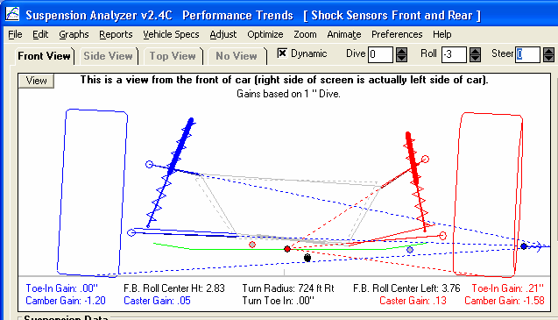
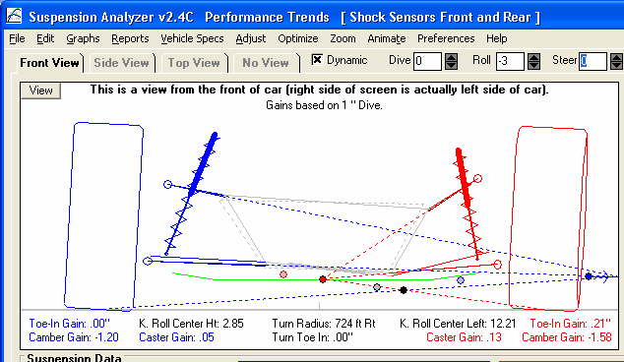
Figure A 6.50 New Force Based Roll Centers

F.B. indicates “Force Based” Roll Center Calculations

Force Base Roll Centers typically do not move around as much with Dive and Roll

K. indicates Kinematic

Kinematic Roll Center moves left as suspension goes through -3 degrees of roll.
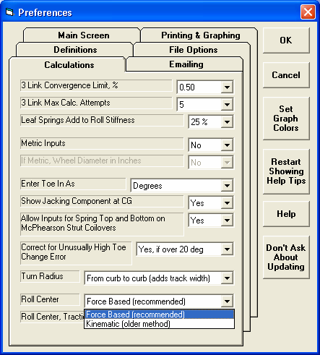
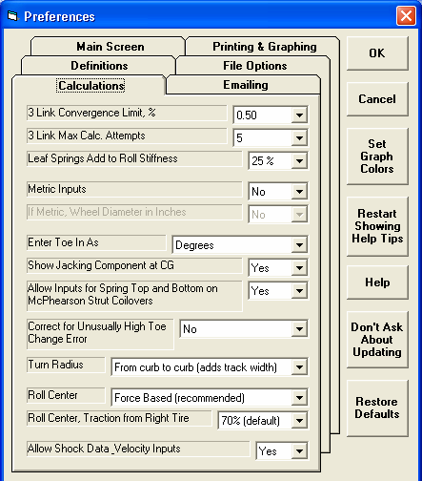

Figure A 6.51 New Preferences: Force Based Roll Centers and Shock Data Analysis

Pick method here

If you pick Force Based, you must specify how much traction is coming from the outside tire in a turn. 70% is a good assumption for most situations.
New Preference to all Shock Data to be entered and analyzed.

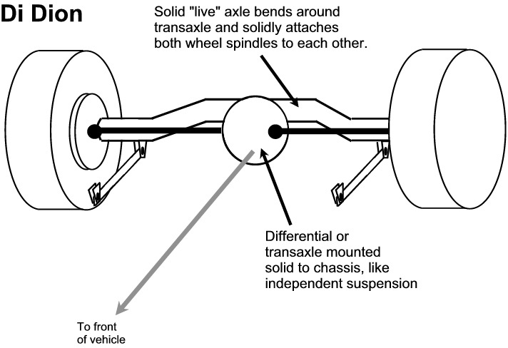
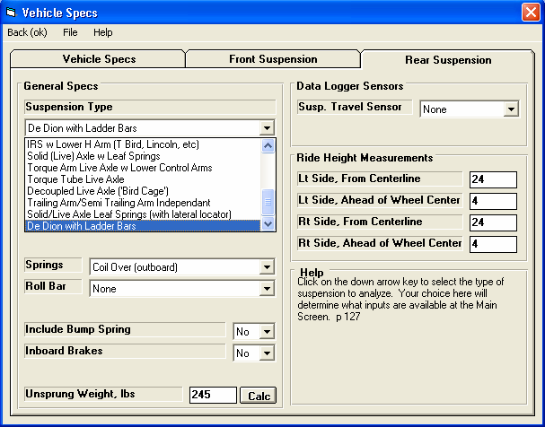

Figure A 6.52 Di Dion Rear Suspension

De Dion choice
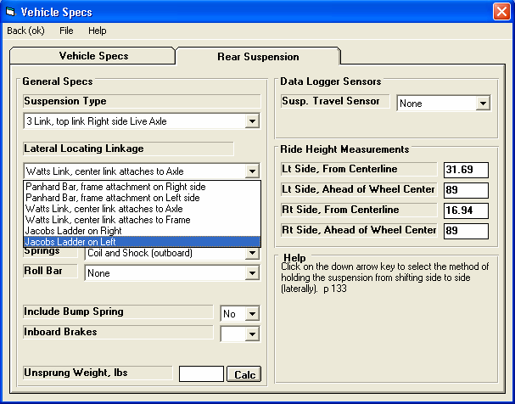
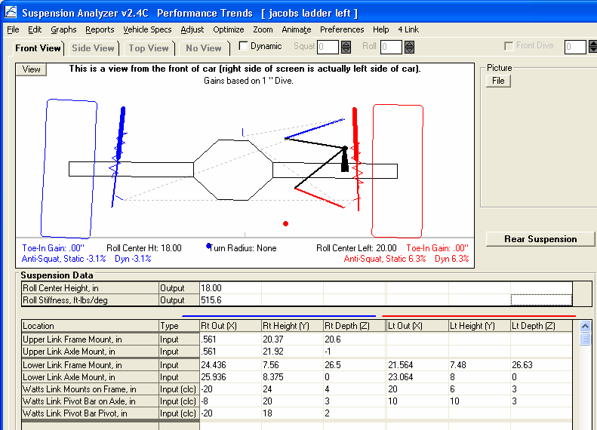
Figure A 6.53 Jacob’s Ladder

Jacob’s Ladder choices

Jacob’s Ladder in drawing

Jacob’s Ladder (special version of Watts Link) inputs
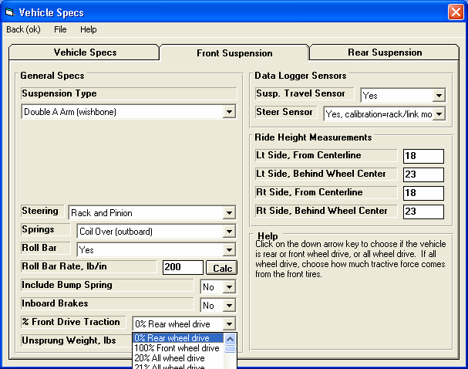

Figure A 6.54 Independent Suspension Half Shaft Motion

Independent suspension type

Your choice here determines if the traction is coming from the front or rear suspension (front or rear wheel drive). If you pick something other than 0% or 100%, the program assumes all wheel drive, that there are half shafts on both suspensions, if they are independent.
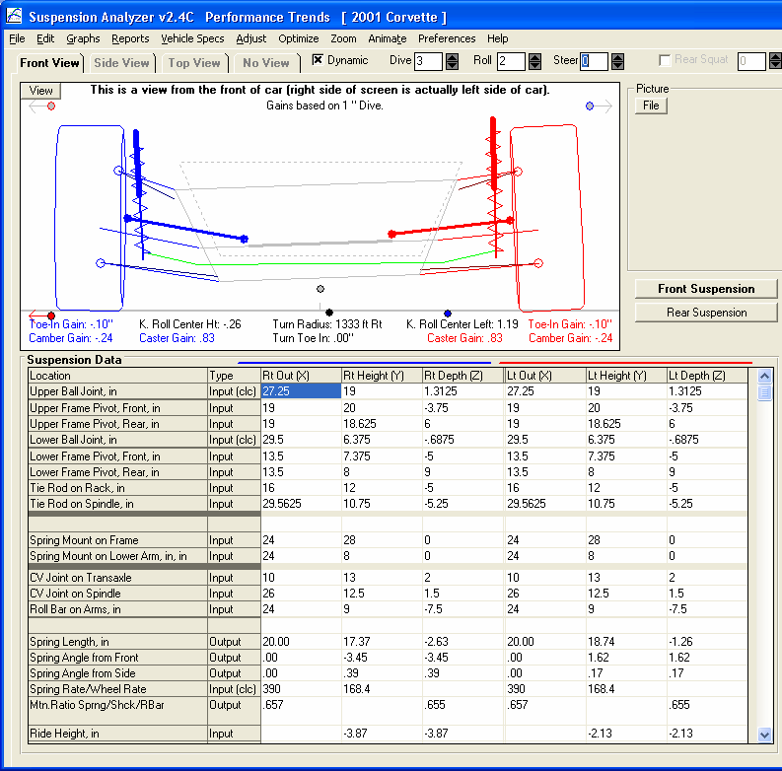
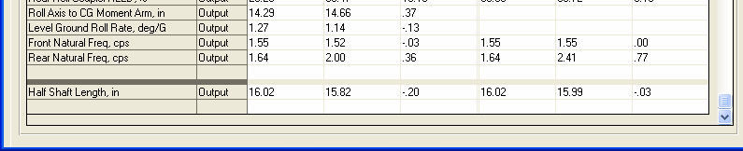

Figure A 6.55 Independent Suspension Half Shaft Motion, cont

Half shafts

CV Joint Locations

Half shaft motion
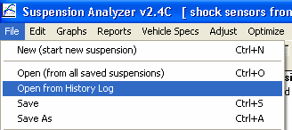
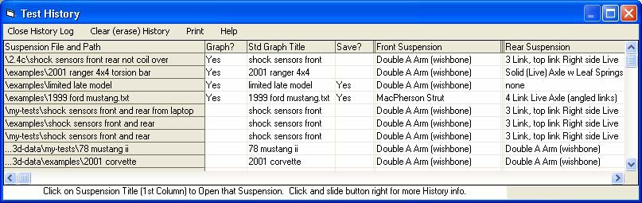
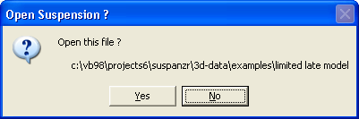
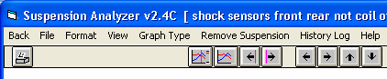
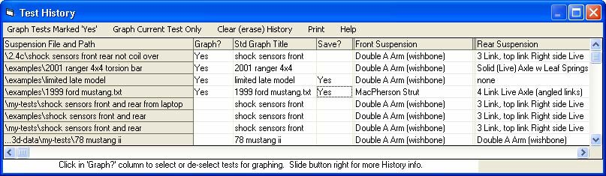
Figure A 6.56 History Log Features
Opening History Log from Main Screen to view recent history and open recently used files.

Click on File Name and Path here to open this file.
Click here to put a Yes in this column to keep this particular file in the History Log.

Click here to erase all files out of the History Log except those marked Yes to “Save?” and the current file in the first row.

In Graph screen, click here to access the History Log.

Click to put a Yes here and this file will be included in the graph. If you pick more than 6, only the first 6 files will be graphed.

Click here to change the title for this file as it will appear on the graph. See Fig A 6.57.
Click here to graph only the current file, the first file in the History Log.
Click here to graph all tests marked Yes, up to 6 test maximum.

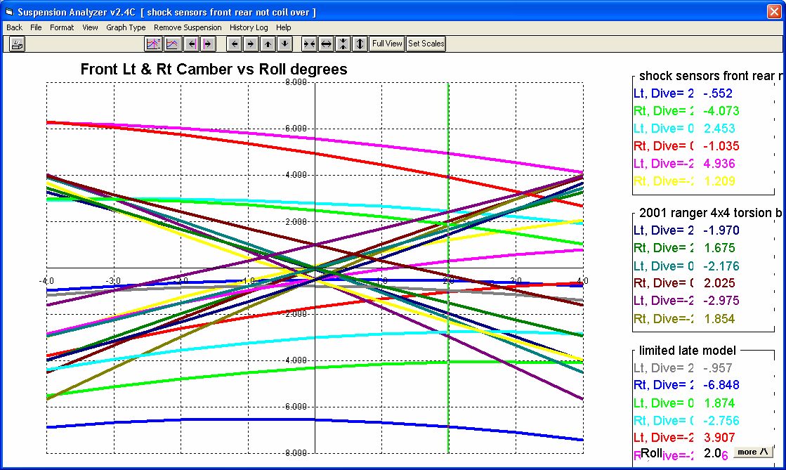
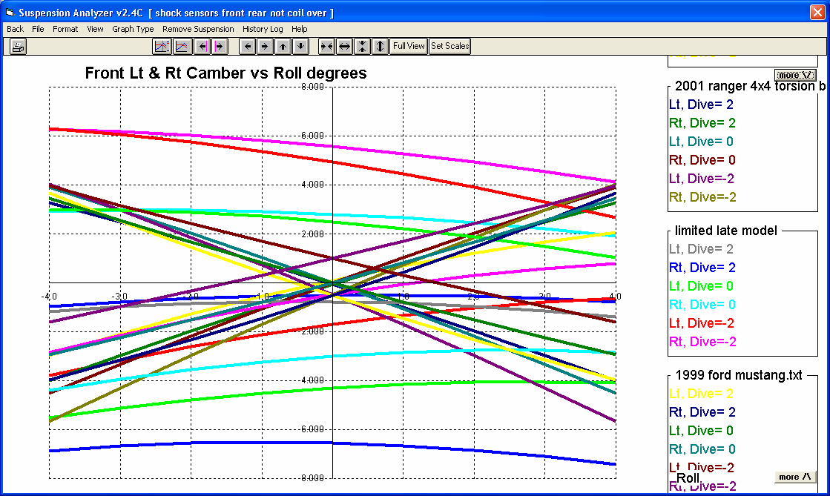
Figure A 6.57 History Log Features for Graph Screen

This is the Std Graph Title, as shown in Fig A 6.56.
If there are more lines in the legend (labels) than can appear on the screen, buttons will appear here to let you scroll them up or down so you can see them all.

A button can also appear here if the labels have extended off the top of the graph.
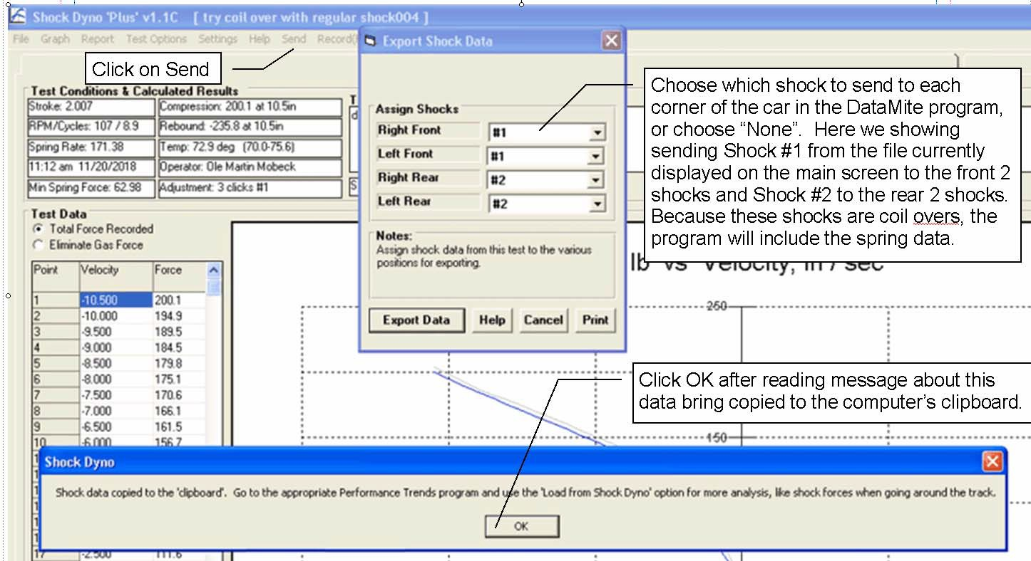
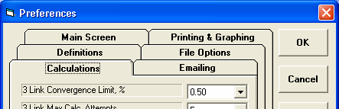
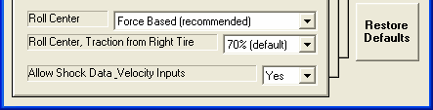
Figure A 6.58 Copying Shock Data from Performance Trends’ Shock Dyno Software

If you have an appropriate Shock Dyno Plus version, you can click on the ‘Send’ option and be presented with the 4 corners of the car. For each corner you can select which shock or coil over’s data to send, or choose “None” for that particular corner. You may have to open other Shock Dyno files, do the Send and select different corners of the car for sending shock data for different shocks.

As shown in the picture, the Export Data will copy this data to the computer’s clipboard. This is the same process as doing a Windows Ctrl-C or a Copy process. Therefore, do not do a copy or paste command before you go to your Suspension Analyzer program to import this data.

You must turn on this Preference before you can do any Shock Data Analysis in the Suspension Analyzer
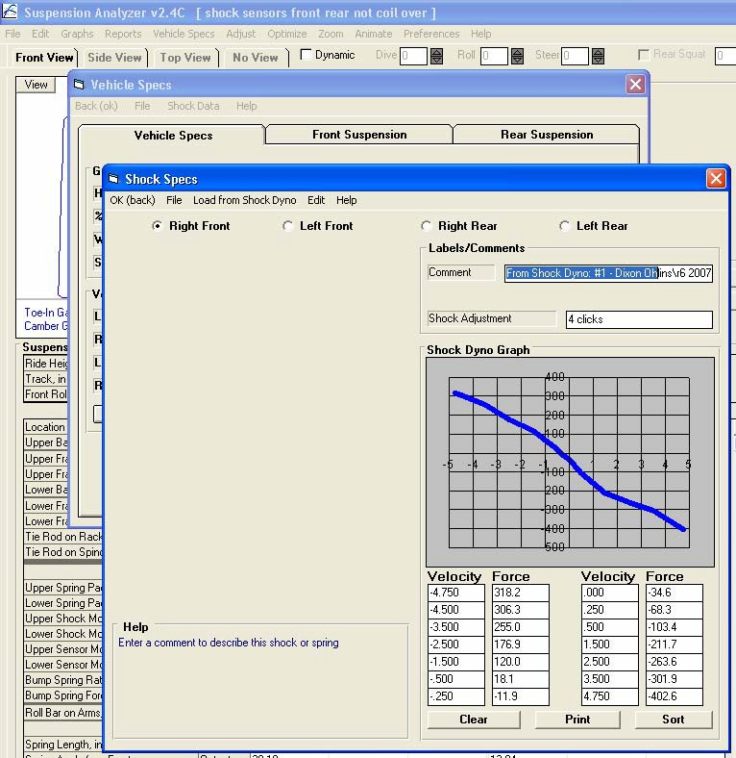
Figure A 6.59 Shock Data Screen
Click Vehicle Specs
Click Shock Data

Edit options let you copy data from one Shock Absorber position to a different one.

Click here for showing data for different shocks.

General information, which may be imported from Performance Trends Shock Dyno program or that you may enter for your own information.
Typical graph slopes from upper left down to lower right. That is because negative velocity is the shock compressing, but that produces a positive force.

Manually enter data from a shock dyno graph, or import from Performance Trends Shock Dyno program.

If you enter data out of order, say at -5”/sec, then 2”/sec, then -1”/sec, the graph will look strange. Click this Sort button and the program will rearrange you data starting with lowest velocity first going up to highest velocity.
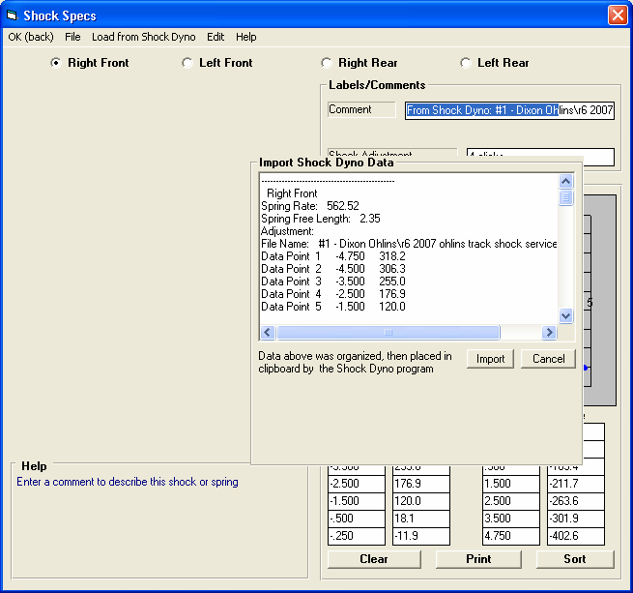
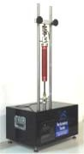
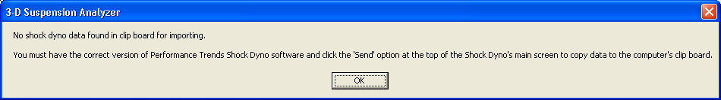
Figure A 6.60 Importing Shock Data from Performance Trends’ Shock Dyno Software

Click here and this new frame will appear with the shock data loaded from the clipboard displayed.
Performance Trends’ Shock Dyno

Click the Import button to import the proper data to the proper Shock Absorber positions, Right Front, Left Front, etc. This will be as you directed in the Shock Dyno software.
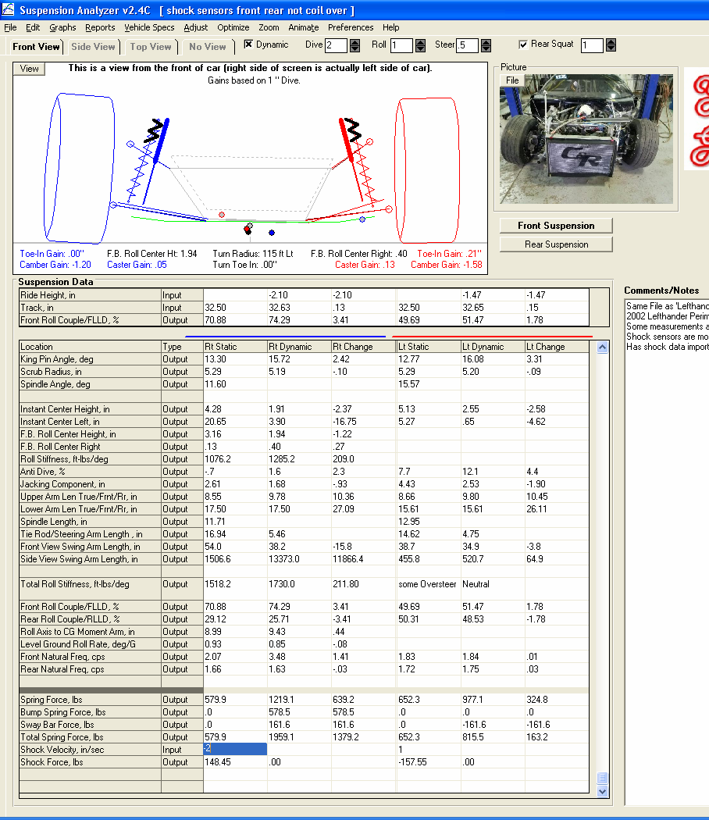
Figure A 6.61 Spring and Shock Force Data, manual inputs

The resultant shock force is displayed here.
You can manually enter a shock velocity here. A negative velocity means the shock is compressing.
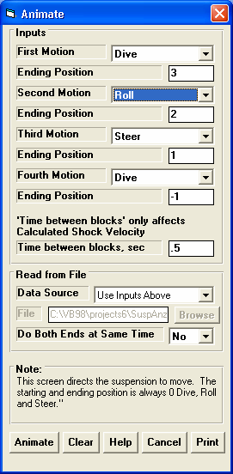
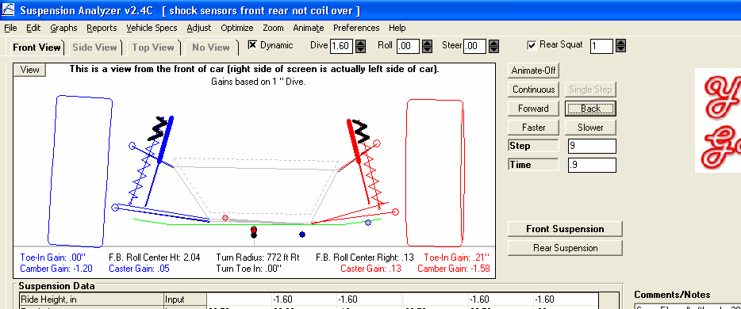
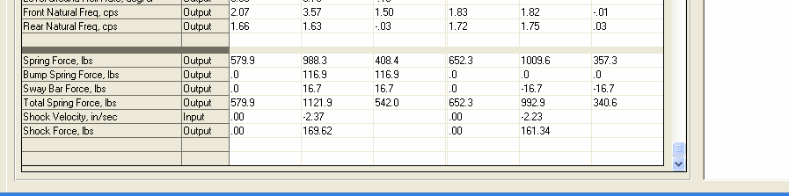
Figure A 6.62 Spring and Shock Force Data, Simple Animation

New input in the Animate screen of “Time between blocks, sec”. This is used to calculate a Shock Velocity in this Simple Animation mode. For example, the Animation starts at 0 Dive, 0 Roll and 0 Steer. In this screen, the Ending Position for the first block is 3. With a “Time between blocks, sec”, of 0.5 seconds, this means the vehicle will dive 3” in 0.0 seconds. This info along with the motion ratio of the shock will determine the resulting shock velocity.

Calculated Shock Velocity and the resultant Shock Force for this Simple Animation.
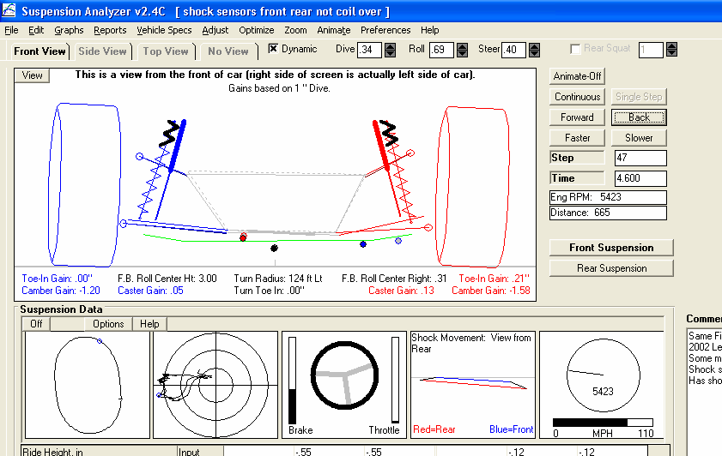
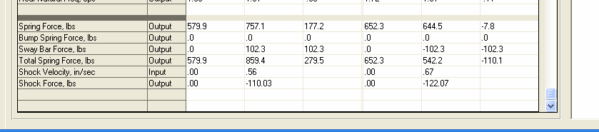
Figure A 6.63 Spring and Shock Force Data, Animation from Data Logger File

Dive, Roll and Steer from data logger sensors.

Data logger time, which determines the shock velocity.

Shock Force calculated from the Shock Velocity determined by the program and the corresponding force from the Shock Dyno data tables.
Shock Velocity calculated from the change in shock length data and the time between data points. This velocity is most accurate once the program has displayed all time steps. That way the program knows both the shock length before and after the time step being displayed. Until that time, the program only knows the shock length for the current time step and the last time step, and not the next time step.
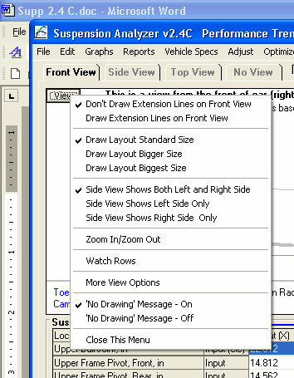
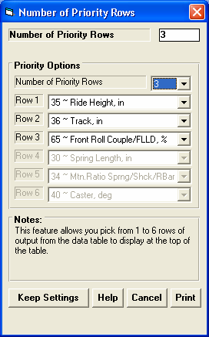
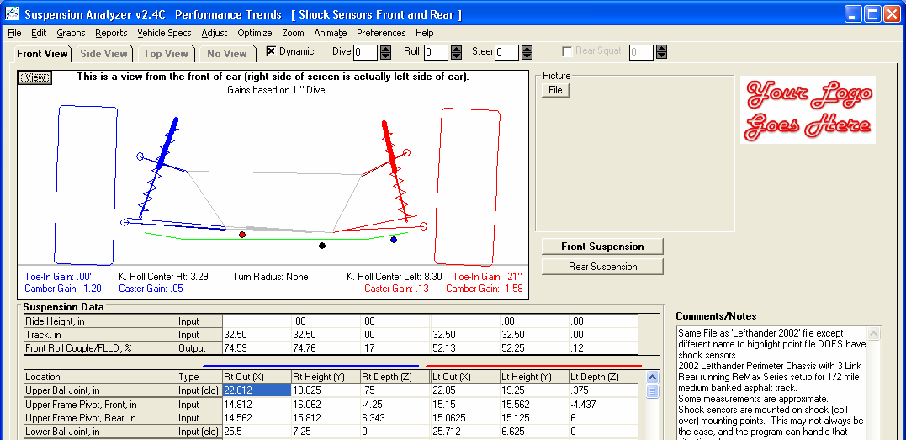
Figure A 6.64 Watch Rows to Watch Data of Particular Interest

Choose Watch Rows

Watch Rows section
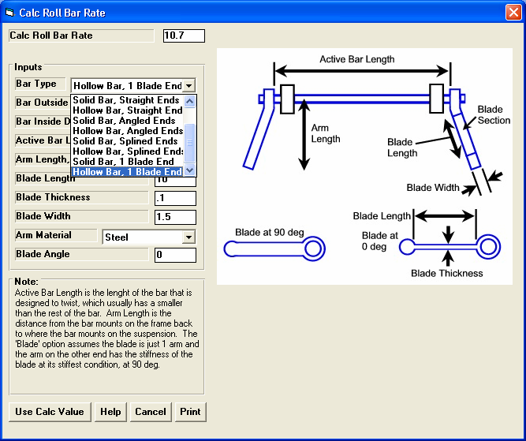
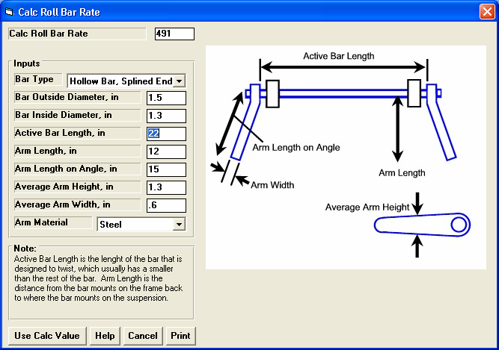
Figure A 6.65 More Detailed and Accurate Anti-Roll Bar Calculation Utility

Several new choices which account for flex in the arms, and the new “blade” option which has adjustable flex.

Drawing helps explain inputs.

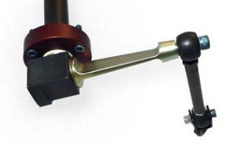
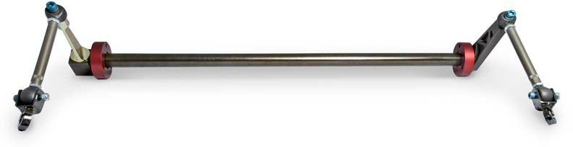
Figure A 6.66 Blade Anti-Roll Bar

photos courtesyelephantracing.com
Blade on bar shown at approximately 80 degrees.
Closeup of blade, shown at approximately 0 degrees.
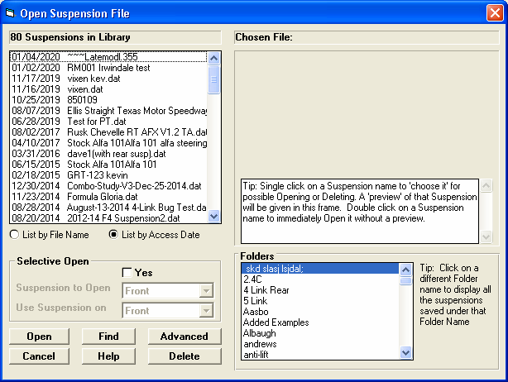
Figure A 6.67 List Files by Access Date
Click here for new list option.
Access Date shown here, with most recently accessed files at the top of this list.
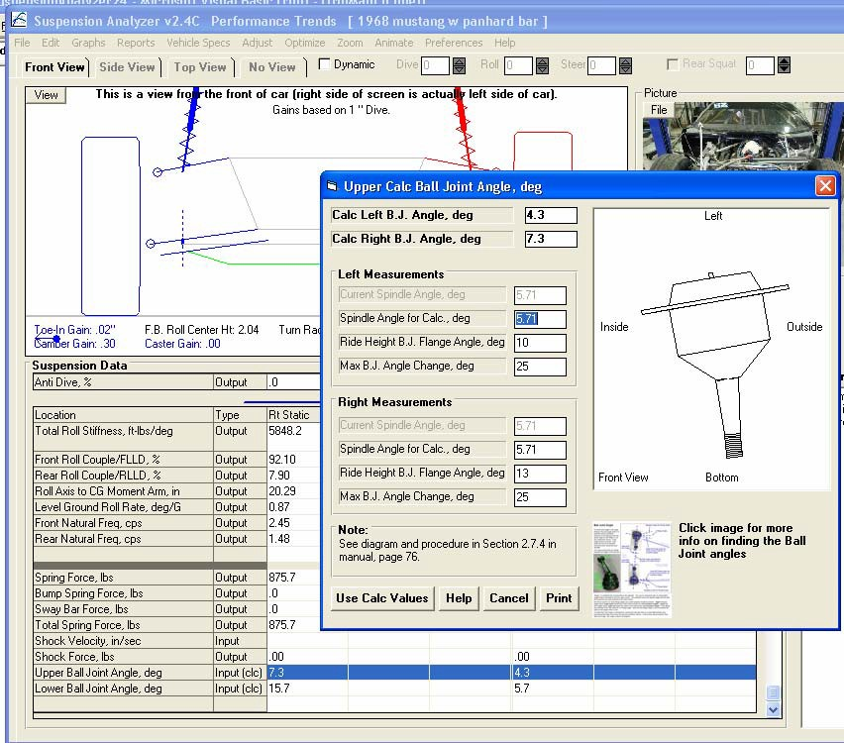
Figure A 6.68 Ball Joint Angle Movement

This is the Current Spindle Angle, which may not match the Spindle Angle used for the Calculation. These may not match if you have changed ball joint locations on the main screen since you last used this screen. In most cases you will change the Spindle Angle used for the Calculation to match Current Spindle Angle.

Enter the Max Ball Joint Angle

Click here or here for help shown on next screen.
Click here to load the “Calc Left/Right B.J. Angle, deg” numbers at the top back onto the main screen’s table.
Ball Joint Angles show up at the bottom of the table. You can enter the Ride Height Ball Joint Angles directly, shown here as 7.3 and
4.3 degrees on the Upper, 15.7 and 5.7 on the Lower. Or you can click on the “Input (clc)” field to open up the Calculation Utility shown above. In this screen, the ball joint picture is updated as you change angles to show you how your inputs are affecting the “Calc Left/Right B.J. Angle, deg” numbers at the top.

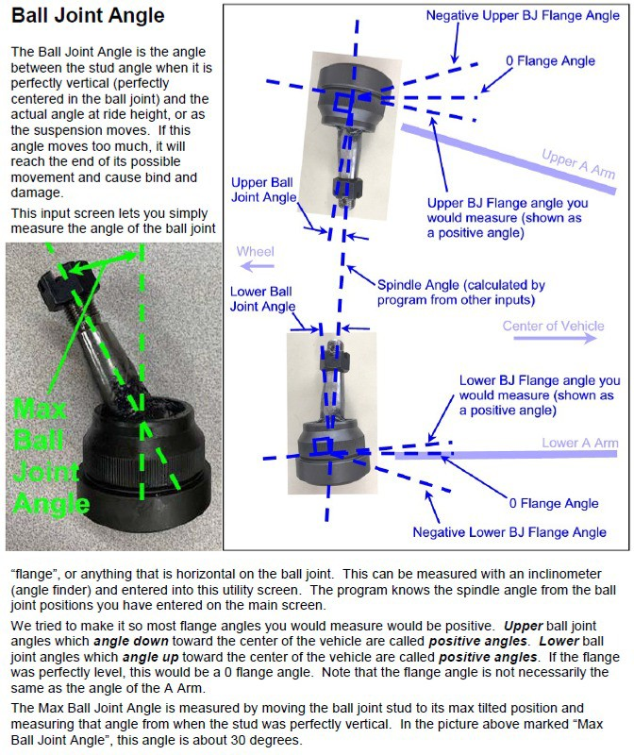
Figure A 6.69 Ball Joint Angle Movement Help Screen
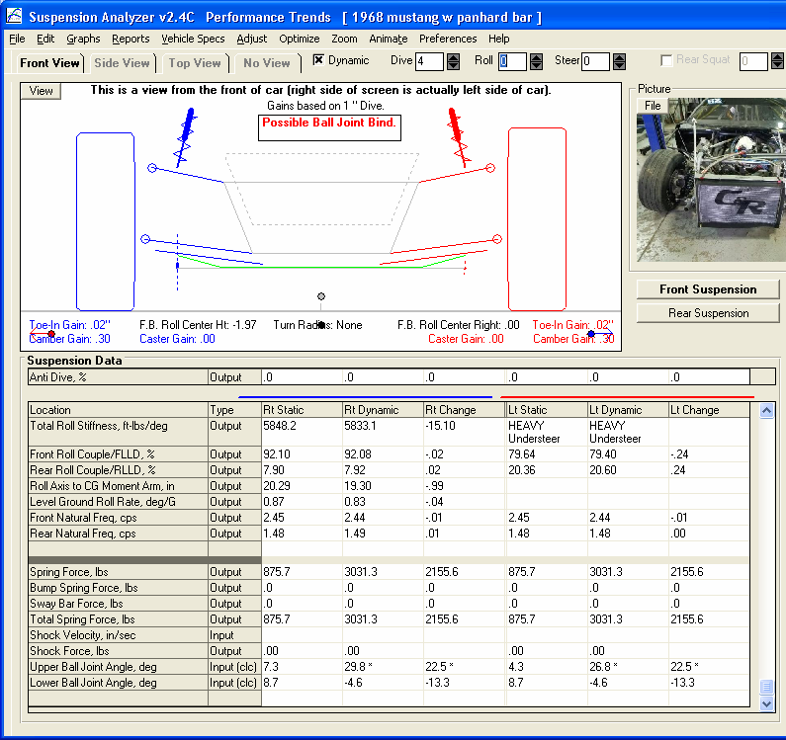
Figure A 6.70 Ball Joint Angle Movement Results

Bind called out here.

Asterisks show Max Ball Joint Angle Exceeded.
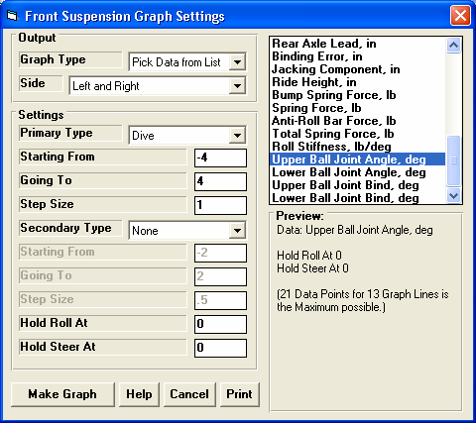
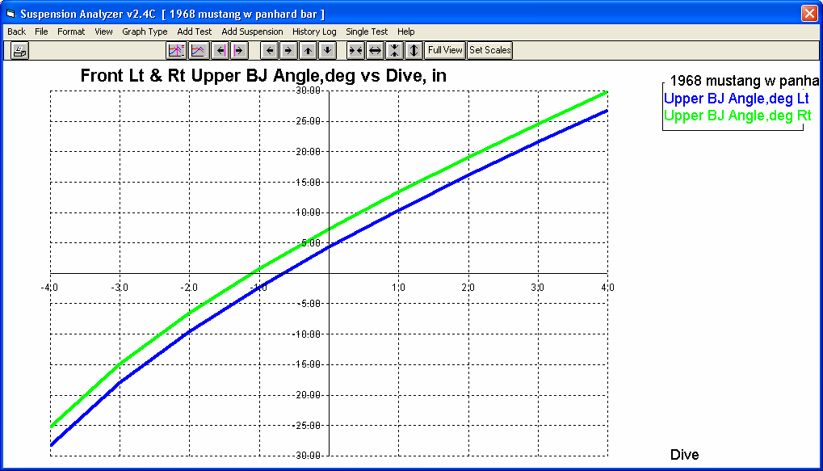
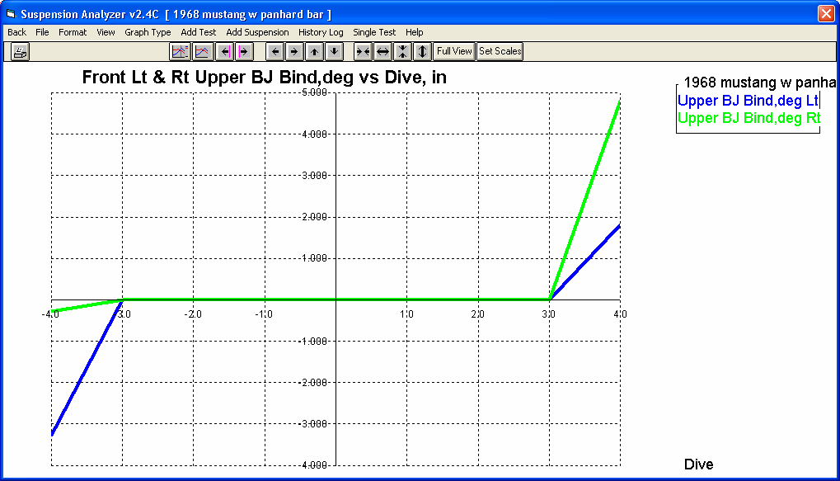
Figure A 6.71 Ball Joint Angle Movement Graph

Second graph was done by selecting this “Bind” option.

Graphing the Angle.

Graphing Bind.

